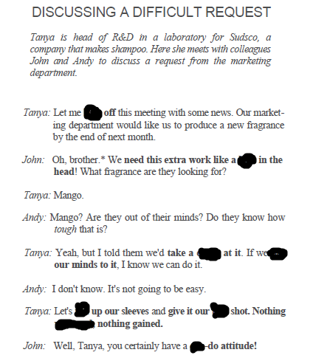



**roll , can , put, crack , roll , hole, kick, ventured**